
CSI wanted to share highlights from additional lung competitors Q1 earnings calls:

BioNTech reported its Q1 2025 financial results and held an accompanying investor call (Results | Presentation)

Analysts were very interested in BNT327/PM8002 (PD-L1 x VEGF bsAb) as backbone for its NSCLC program, and comparing the agent to Summit’s P3 ivonescimab and Merck’s P1 PD-1/VEGF bsAb agents. BNT327 is in a global P3 in 1L SCLC and 1L NSCLC, both in combination with chemotherapy

- BNTX views combinations with chemotherapy as the “fastest path to market…capable of replacing first-generation CPIs,” but emphasized the longer-term strategy to combine BNT327 with its pipeline of ADCs, bispecifics, and mRNA cancer vaccines
- When asked about potential pivotal trials in 2L EGFRm NSCLC–Summit’s first expected approval in Western markets in 2026 -- BNTX is “keeping the option open” in light of its “very encouraging” data at ESMO 2024 in both PD-L1 positive and negative patients in combination with chemotherapy [[Kate to add cross trial comparison of the two agents once data received]]
- When asked to compare the molecular design of BNT327 to Summit and Merck’s bispecifics, BNTX offered:
  - “We have deliberately chosen …PD-L1 versus the PD-1 because we expect from PD-L1 that it might be superior to PD-1 in anchoring, in particular, in the tumor microenvironment where we want to have the bispecific. And also, the molecular format with a full – an IgG VEGF – anti-VEGF portion and VHH PD-L1 portion was compelling to us because we think that we get the right pattern of cross-ligation in the tumor microenvironment.” [[Kate to clarify]]

BNTX provided an update to its global P3 in 1L non-oncogene NSCLC: ROSETTA_Lung-02 of BNT327 + CT vs SOC pembrolizumab + CT, which is enrolling

- Q1 update: Recall the trial launched in January 2025 and the P2 portion is now enrolling. Management expects progression into P3 portion in 2025. The complete trial design will be presented at ASCO
- The trial is enrolling both NSQ and SQ histologies across all PD-L1 subgroups in two separately powered substudies
- The trial has a P2 component (n=40) to establish the P3 dose
- The randomized P3 portion (n=942) has two co-primary endpoints: PFS and OS

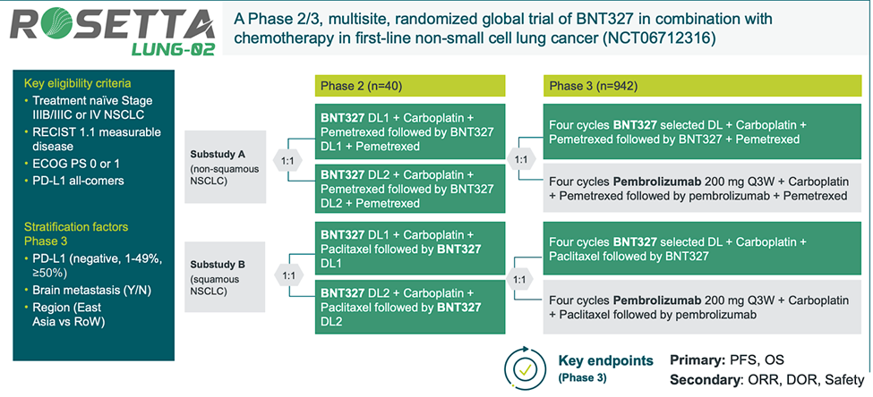

When asked about Akeso/Summit’s news of ivonescimab (PD-1/VEGF bsAb) trending OS benefit at early interim in 1L PD-L1≥1% in China P3, BNTX said the news is “very encouraging.” Akeso’s study “has no direct impact” on BNTX NSCLC program, because ROSETTA-Lung02 is in combo with chemotherapy and in a “different population” (PD-L1 all comers vs Akeso’s in PD-L1≥1%)

Other Commentary:

- BNTX plans to submit a BLA for its shared ADC with Duality Bio, BNT323 (HER2 Top1) in 2L endometrial cancer, in 2025. The asset is also in a P3 in TNBC.
- Anticipating a 2026 launch, BNTX has begun expanding its commercial capabilities in oncology by establishing a global commercial leadership team and a U.S general manager [[Kate the clarify which indication and if it’s a global launch]]


Genmab announced its Q1 2025 earnings and held an accompanying investor call (presentation | press release)
Data from the ongoing global P2 trial evaluating acasunlimab (PD-L1 x 4-1BB bsAb) as a monotherapy and in combination with pembrolizumab in 2L+ NSCLC is anticipated 2H 2025

- Genmab noted they have pursued a longer follow up so that the OS data would be “more meaningful…to support beating docetaxel with a median of 11 months.”
- The trial reached PCD in December 2024
- The trial enrolled 125 patients and assessed multiple doses of the acasunlimab + pembro combination and evaluated efficacy in a randomized 1:1:1 design (aca monotherapy vs. aca+pembro Q3W vs. aca+pembro Q6W)

The global P3 ABBIL1TY NSCLC-06 trial evaluating acasunlimab + pembrolizumab combo therapy over docetaxel in 2L+ NSCLC patients who have failed IO and platinum chemo is recruiting with topline data expected 2027

- The trial plans to enroll 702 patients without AGAs and has one primary endpoint - OS
- Recall Genmab independently launched the trial in November 2024 following BioNTech backing out of its collaboration to develop the asset in August 2024
- Genmab anticipates a $1B sales opportunity for this patient population and is eyeing a 2028 launch for acasunlimab in NSCLC

Genmab opened 2 NSCLC expansion cohorts in its P1/2 PRO1184-001 evaluating rinatabart sesutecan (Rina-S, FRα Top1 ADC) monotherapy in advanced solid tumors

- One cohort is dedicated to EGFRwt patients, the other to EGFRm patients
- Patients must have failed prior therapies – though few specifics are provided
- Genmab is “actively enrolling” NSCLC patients and plans to share data “very soon”
- The ADC is one of Genmab’s lead assets and is currently under investigation in a P3 trial for platinum-resistant ovarian cancer with a P3 for endometrial cancer planned to launch later this year
- Genmab intends to expand the asset further outside of PROC, EC, and NSCLC to multiple solid tumors based on encouraging data

Genmab continues to receive royalties of 8-10% of J&J’s RYBREVANT (amivantamab, EGFR x cMET bsAb) global sales

- Recall Genmab and J&J entered a research collaboration in December 2013 for the asset

